CUDA Installation Guide for Linux:

First you need to install the Nvidia Driver from Terminal:

* **sudo apt-get install nvidia-driver-450**

Then Download the the CUDA run file from Nvidia Website:

<https://developer.nvidia.com/cuda-11.2.0-download-archive?target_os=Linux&target_arch=x86_64&target_distro=Ubuntu&target_version=1804&target_type=runfilelocal>

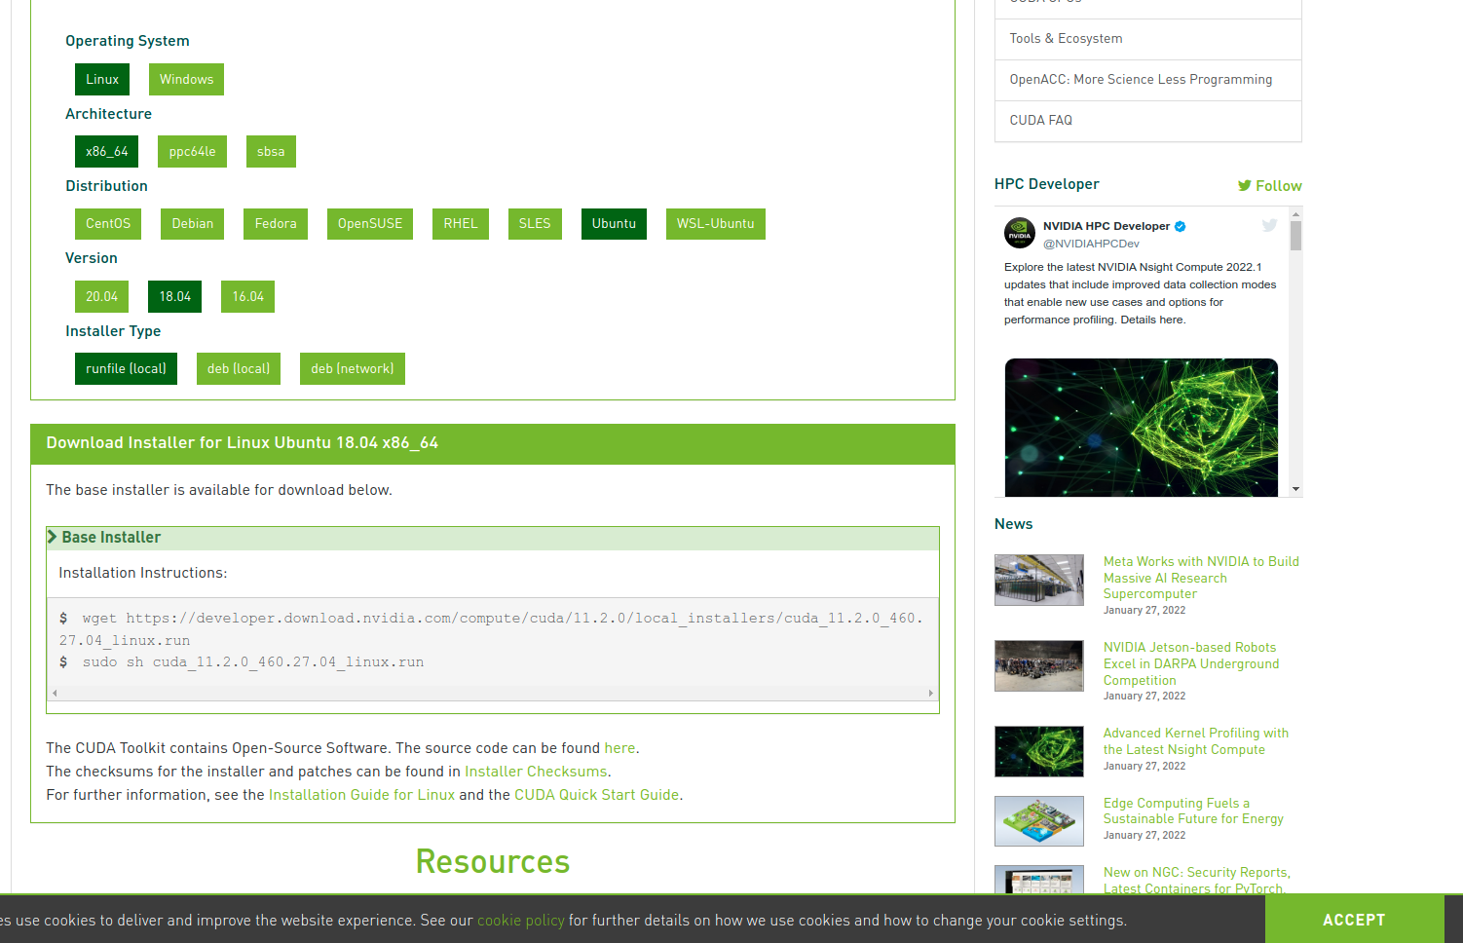

* sudo sh cuda_11.2.0_460.27.04_linux.run

Then you need to install the Torch version compatible with CUDA:

* pip install torch==1.9.0+cu111 torchvision==0.10.0+cu111 torchaudio==0.9.0 -f <https://download.pytorch.org/whl/torch_stable.html>

Torch for C++

* Installing CUDNN tar file (instructions on NVIDIA)
* Cudnn-linux-x86_64-8.9.2.26_cuda11-archive.tar.xz

CMAKE:

set(CMAKE_PREFIX_PATH /home/bluesky/Downloads/libtorch-cxx11-abi-shared-with-deps-1.8.0+cu112/libtorch)

find_package(Torch REQUIRED)

set(CMAKE_CXX_FLAGS "${CMAKE_CXX_FLAGS} ${TORCH_CXX_FLAGS}")

Executable

add_executable(uav_torch_ src/af_torch.cpp)

target_link_libraries(uav_torch_ ${catkin_LIBRARIES})

target_link_libraries(uav_torch_ ${TORCH_LIBRARIES})

set_property(TARGET uav_torch_ PROPERTY CXX_STANDARD 14)

Copying libtorch into /opt/ros/noetic/share